Project Planning Phase
Project Planning Template (Product Backlog, Sprint Planning, Stories, Story points)
Date | 15 February 2025
Team ID | SWTID-2026-3677
Project Name | Auto Ticket Classification using Flow Designer
Maximum Marks | 5 Marks

Product Backlog, Sprint Schedule, and Estimation (4 Marks)
Use the below template to create product backlog and sprint schedule
Sprint | Functional Requirement (Epic) | User Story Number | User Story / Task | Story Points | Priority | Team Members
Sprint-1 | ServiceNow Setup | USN-1 | As an admin, I can set up a ServiceNow developer instance to build the ticket classification solution. | 2 | High | Team Member 1
Sprint-1 |  | USN-2 | As an admin, I can create categories and assignment groups so that tickets can be classified and routed. | 1 | High | Team Member 1
Sprint-1 | Ticket Data Preparation | USN-3 | As an admin, I can define classification rules and keywords for each ticket category. | 3 | High | Team Member 2
Sprint-1 |  | USN-4 | As an admin, I can create custom fields for category and priority on the incident form. | 3 | Medium | Team Member 3
Sprint-1 |  | USN-5 | As an admin, I can handle inconsistent ticket descriptions so that classification works reliably. | 3 | Medium | Team Member 4
Sprint-2 | Flow Designer Automation | USN-6 | As an admin, I can create a flow trigger that runs when a new ticket is created. | 2 | High | Team Member 2
Sprint-2 |  | USN-7 | As an admin, I can make the flow read the ticket's short description and description. | 2 | High | Team Member 3
Sprint-2 |  | USN-8 | As an admin, I can apply classification conditions to match each ticket to a category. | 2 | High | Team Member 4
Sprint-2 |  | USN-9 | As a support agent, I receive tickets with the category, priority and assignment group updated automatically. | 4 | High | Team Member 5
Sprint-2 | Testing | USN-10 | As a team, we can test the flow with sample tickets to confirm they are classified correctly. | 5 | High | Team Member 4
Sprint-2 | Notification and Reporting | USN-11 | As a requester, I receive an email notification, and as a manager I can view a dashboard of classified tickets. | 5 | Medium | Team Member 5
Project Tracker, Velocity & Burndown Chart: (4 Marks)
Sprint | Total Story Points | Duration | Sprint Start Date | Sprint End Date (Planned) | Story Points Completed (as on Planned End Date) | Sprint Release Date (Actual)
Sprint-1 | 12 | 6 Days | 05 Oct 2026 | 10 Oct 2026
Sprint-2 | 20 | 6 Days | 12 Oct 2026 | 17 Oct 2026

Velocity:
Imagine we have a 10-day sprint duration, and the velocity of the team is 20 (points per sprint). Let’s calculate the team’s average velocity (AV) per iteration unit (story points per day)
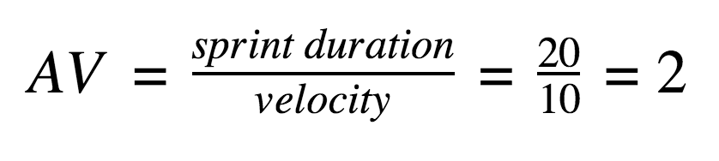
For this project: total story points = 12 + 20 = 32 over 2 sprints, so velocity = 32 / 2 = 16 story points per sprint. With a 6-day sprint, the average velocity is 16 / 6 ≈ 2.67 story points per day.
Burndown Chart:
A burn down chart is a graphical representation of work left to do versus time. It is often used in agile software development methodologies such as Scrum. However, burn down charts can be applied to any project containing measurable progress over time.
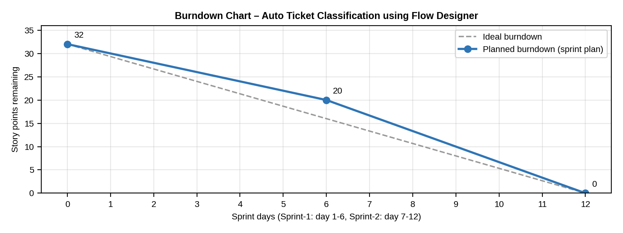
https://www.visual-paradigm.com/scrum/scrum-burndown-chart/
https://www.atlassian.com/agile/tutorials/burndown-charts
Reference:
https://www.atlassian.com/agile/project-management
https://www.atlassian.com/agile/tutorials/how-to-do-scrum-with-jira-software
https://www.atlassian.com/agile/tutorials/epics
https://www.atlassian.com/agile/tutorials/sprints
https://www.atlassian.com/agile/project-management/estimation
https://www.atlassian.com/agile/tutorials/burndown-charts

